General Notes 2
Claiming Piping Parts 2
Defining the Value of the “Active WBS Project” Field 2
Claiming Piping Parts During Creation 3
Claiming Piping Parts After Creation 3
Releasing a Claim on Piping Parts 4
Grouping Piping Parts 5
The “Isometric Sheet Number” Property 5
The “Group Pipe Parts” Command 6
Generating Isometric Drawings 9
Adding the “WBS_Isometrics_DwgByQMgr” Component 9
Configuring the “WBS_Isometrics_DwgByQMgr” Component 10
Querying for WBS Items with Related Piping Part Groups 11
Creating Isometric Drawings 12
Updating Isometric Drawings 13

Creation of SmartPlant 3D Isometric Drawings
with Pre-Defined Sheet Splits

The following document details the creation of piping isometric drawings that are split according to the value of the “Isometric Sheet Number” property on the property page of the piping part.

General Notes
- The WBS project claiming functionality described in this document pertains to a non-integrated SmartPlant 3D modeling environment.
- The workflow defined in this document assumes that any customized isometric options have been previously configured.
- Before claiming piping parts to a WBS project or utilizing the “Group Pipe Parts” command, at least two WBS projects must be created:
  - One project for which the value of the “Project Purpose” property has been set to “As-built” (Note: SmartPlant 3D does not allow the creation of more than one “as-built” project in a plant.)
  - One (or more) project(s) for which the value of the “Project Purpose” property has been set to “Project”

Claiming Piping Parts
Before piping parts created in SmartPlant 3D can be grouped for isometric drawing creation, they must be claimed to a WBS project. This can be accomplished either during or after part creation. Prior to claiming one or more piping parts to a WBS project, the desired WBS project must be specified as the value of the “Active WBS Project” field.

Defining the Value of the “Active WBS Project” Field
Before piping parts can be claimed to a WBS project, the desired project must be selected as the value of the “Active WBS Project” field, located in the common (main) toolbar adjacent to the “Active Permission Group” field.

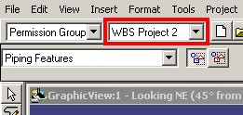

Projects selected previously during the current SmartPlant 3D session can be selected from the associated pull-down list. Additionally, selection of the “More…” entry results in the display of the “Select Active Project” dialog which facilitates selection of any available WBS project, regardless of whether it has been included in the current workspace definition.

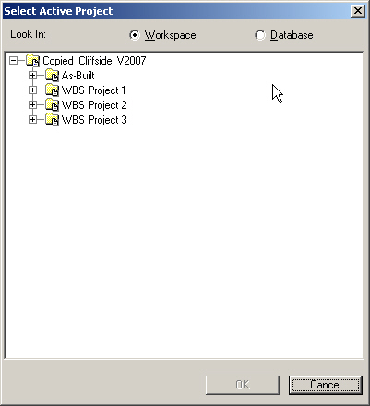

Claiming Piping Parts During Creation
Once an active WBS project has been selected, piping parts are automatically claimed by that project as they are created. No additional work is required by the designer.

Claiming Piping Parts After Creation
After creation, piping parts can be claimed to the active WBS project in the following manner:

- If not already defined, select a value in the “Active WBS Project” field. See the "Defining the Value of the 'Active WBS Project' Field" section for more information.
- Select one or more piping parts to be claimed to the active WBS project.
- Select Project > Claim from the SmartPlant 3D menu.

  - If the selected piping parts have previously been claimed to another WBS project, a dialog will appear stating that the selected piping parts have previously been claimed. Claim of these piping parts to the active WBS project can only be completed after the previous claim has been released. See the "Releasing a Claim on Piping Parts" section for more information.

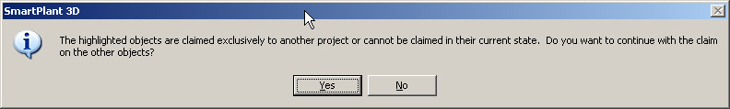

  - If the selected piping parts have not previously been claimed to another WBS project, or if the piping parts have previously been claimed to the active WBS project, a dialog will appear stating that the claim completed successfully.

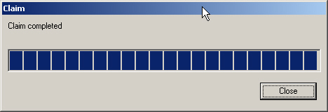

Releasing a Claim on Piping Parts
Before piping parts previously claimed to another WBS project can be claimed to the active WBS project, the previous claim must be released in the following manner:

- Select one or more previously claimed piping parts.
- If not already the current value, select the project to which the selected parts were previously claimed in the “Active WBS Project” field. See the "Defining the Value of the 'Active WBS Project' Field" section for more information.
- Select Project > Release Claim from the SmartPlant 3D menu.

  - If the piping parts have previously been claimed to the active WBS project, a dialog will appear stating that the claim was released successfully.

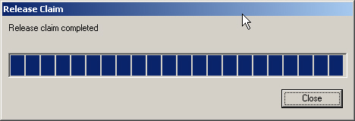

  - If the selected piping parts have not previously been claimed to the active WBS project, two dialogs will be displayed: the first stating that the claim could not be released and the second informing the user that parts claimed to the active WBS project must be selected before activating the “Release Claim” command.

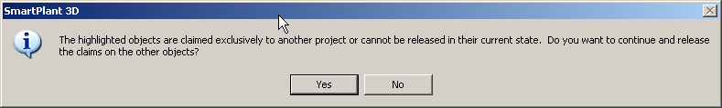

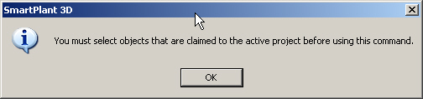

Grouping Piping Parts
Once piping parts have been claimed to a WBS project, they must be grouped for isometric creation. This grouping is performed automatically by the “Group Pipe Parts” command. Prior to being grouped, however, each piping part must have a value defined for its “Isometric Sheet Number” property.

The “Isometric Sheet Number” Property
Prior to activation of the “Group Pipe Parts” command, the value of the “Isometric Sheet Number” property should be defined for each piping part that will be grouped by the command. This property, used by the label query when associating the piping parts with different WBS items, is available on the piping part property page.

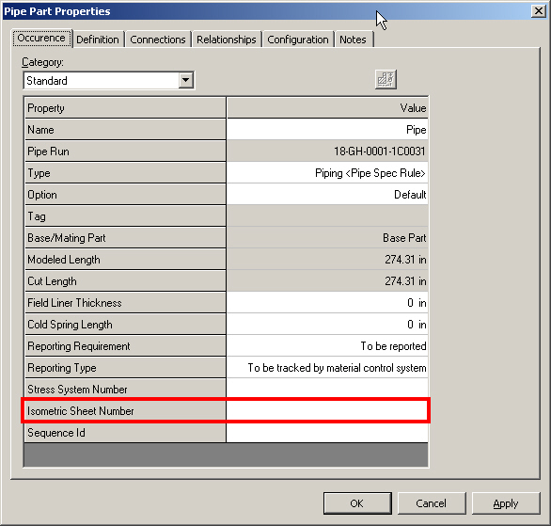

The value defined for this property should correspond to the sheet number on which the piping part will appear when the isometric drawing is generated. Note that this property value can be modified for multiple parts simultaneously as long as the same value is to be applied to all parts. For example, the user can select all piping parts that should appear on sheet two of a particular isometric and specify “2” for the “Isometric Sheet Number” property value. This value will, then, be applied to all piping parts that were selected when the property value was defined.

The “Group Pipe Parts” Command
After each piping part has been claimed to a WBS project and had a value defined for its “Isometric Sheet Number” property, the “Group Pipe Parts” command, available in the SmartPlant 3D “Piping” task, is activated to group the piping parts under automatically created WBS items based on the returned value of a label query. When the command is activated, the “Automated WBS Creation” dialog is displayed. Although values for most properties on the dialog are predefined (according to catalog rule settings) and should not be modified by the user, the values for the “Name Rule,” “Discrimination Filter” and “WBS Item’s Parent” properties must be defined by the user before the command can process successfully.

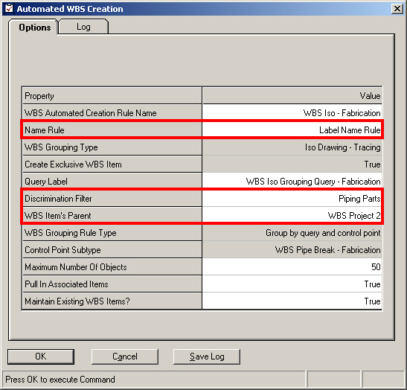

- Name Rule – The value of the “Name Rule” property is the name of a rule that will be used to name the WBS grouping items created by the “Group Pipe Parts” command. The default value for this property is the first available entry in the pull-down list. However, the value should be set to “Label Name Rule” so that the resulting WBS items (and the yet-to-be-created isometric drawings) will be named according to the query label being applied.
- Discrimination Filter – The value of the “Discrimination Filter” property is the name of a filter that will return a select set of piping parts to be considered for grouping. Although the Intergraph-delivered “Piping Parts” filter has been applied in the example image above, any filter returning a set of piping parts can be utilized. The use of a more granular filter will result in fewer piping parts being considered by the grouping command.
- WBS Item’s Parent – The value of the “WBS Item’s Parent” property specifies the name of a WBS item parent under which the grouping items created by the “Group Pipe Parts” command will be placed. Additionally, the value restricts the grouping of those piping parts returned by the Discrimination Filter so that only those parts previously claimed to its WBS project parent (or to itself if it is a WBS project) will be grouped.

After all values have been specified in the “Automated WBS Creation” dialog and the OK button is pressed, SmartPlant 3D groups any returned piping parts and associates each group of parts with a single WBS item created automatically by the “Group Pipe Parts” command.

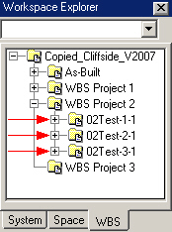

If no errors or warnings are encountered during the grouping process, the command completes with no feedback to the user except for the information reported on the “Log” tab of the “Automated WBS Creation” dialog (Note: An SR has been filed requesting some other form of feedback in addition to the contents of the “Log” tab when the grouping of parts completes with no warnings or errors.).

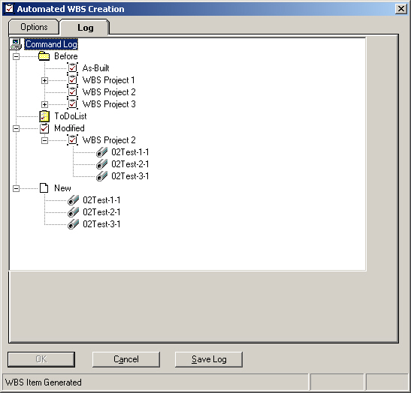

If errors or warnings are encountered during the grouping process, a dialog presenting the user with the opportunity to view a resulting log file is displayed upon completion.

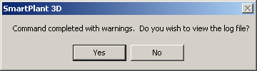

Generating Isometric Drawings
Once piping parts have been grouped and associated with WBS items, isometric drawings can be created in a manner similar to other types of SmartPlant 3D drawings. Generation of isometric drawings using the “WBS_Isometrics_DwgByQMgr” component will result in all piping parts (and only those parts) associated with a single WBS item being included on a single isometric drawing sheet.

Adding the “WBS_Isometrics_DwgByQMgr” Component
The “WBS_Isometrics_DwgByQMgr” component is added as a package in the “Drawings and Reports” task. To add the component:

- Right-click on the desired folder in the “Drawings and Reports” Management Console hierarchy and pick the New… entry from the resulting shortcut menu.
- Once the “Add Component” dialog appears, activate the “Isometrics (by Query)” tab and select the “Shaw_WBS_Isometrics_DwgByQMgr” package. DO NOT SELECT the “Shaw_WBS_Isometrics” package.

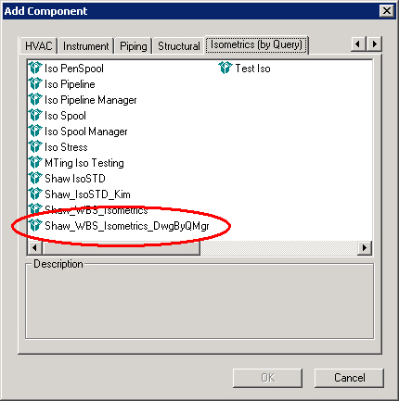

- Press the OK button to close the “Add Component” dialog.
- Verify that a new component node named “WBS_Isometrics_DwgByQMgr” has been created in the hierarchy.

Configuring the “WBS_Isometrics_DwgByQMgr” Component
Once the “WBS_Isometrics_DwgByQMgr” component has been added to the “Drawings and Reports” Management Console hierarchy, it must be configured so that it queries the proper WBS project(s) or item(s) and creates any required subcomponents. Configuration of the “WBS_Isometrics_DwgByQMgr” component is performed in the following manner:

- Right-click on the “WBS_Isometrics_DwgByQMgr” component and pick the Setup… entry from the resulting shortcut menu.

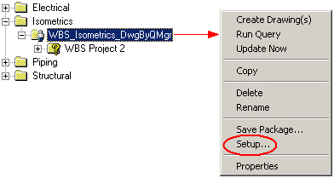

- Once the “Setup” dialog appears, set the value of the “Filter” field to be the name of a filter that will return the desired WBS projects or items (Note: Once the desired WBS structure has been agreed upon, filters created to facilitate proper selection of WBS item(s) will be created and stored in the Plant Filters > Shaw Plant Drawing and Report Filters > Piping > Isometrics > Isometrics Split per WBS Item folder of the “Select Filter” dialog.).
- Do not modify the value of the “Package” field (Note: This field should, by default, have a value of “Shaw_WBS_Isometrics.”).

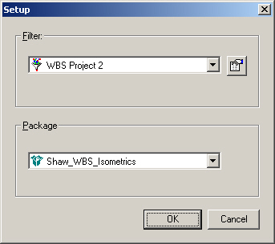

- Press the OK button to accept these values and close the “Setup” dialog.

Querying for WBS Items with Related Piping Part Groups
After the “WBS_Isometrics_DwgByQMgr” component has been added and configured properly, the database can be queried in search of WBS items with related piping part groups by right-clicking the “WBS_Isometrics_DwgByQMgr” component and picking the Run Query entry from the resulting shortcut menu.

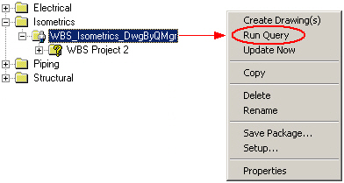

If multiple components have been configured at multiple locations in the hierarchy, the database can be queried for all of them simultaneously simply by right-clicking any component or folder that functions as a hierarchal parent of all of the desired components and picking the Run Query entry from the resulting shortcut menu.

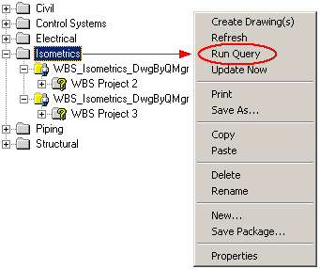

If the query is successful and one or more WBS items with related piping part groups are returned, a folder structure matching that of the returned WBS items will appear under the “WBS_Isometrics_DwgByQMgr” component. Additionally, in the bottom folder of each branch of the newly created folder structure, a new component named “WBS_Isometrics” will appear. It is under this component that the actual isometric drawings are created.

If the query is unsuccessful and no WBS items with related piping part groups are returned, a dialog appears informing the user of this fact.

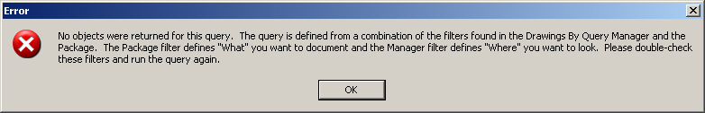

Creating Isometric Drawings
Once any necessary “WBS_Isometrics_DwgByQMgr” components have been added to the “Drawings and Reports” Management Console hierarchy and queries have been run successfully, the isometric drawings must be created. This is accomplished by right-clicking the “WBS_Isometrics” component under the desired “WBS_Isometrics_DwgByQMgr” component and picking the Create Drawing(s) entry from the resulting shortcut menu.

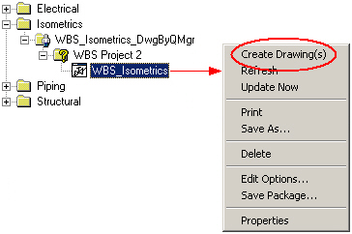

If multiple “WBS_Isometrics” components have been created at multiple locations in the hierarchy, drawings can be created for all of them simultaneously simply by right-clicking any component or folder that functions as a hierarchal parent of all of the desired components and picking the Create Drawing(s) entry from the resulting shortcut menu.

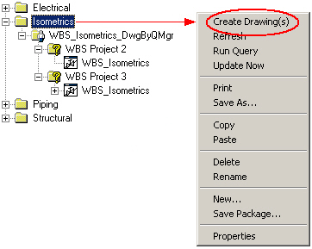

If drawing creation is successful, drawings will appear in the “Drawings and Reports” Detail View window for each “WBS_Isometrics” component for which the “Create Drawing(s)” entry was selected.

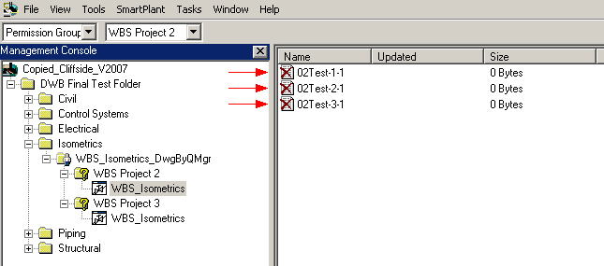

Updating Isometric Drawings
Initial creation of an isometric drawing produces nothing more than an empty container that must be populated with information before it is useful. This information (pipeline representation, material takeoff, title block data, etc.) is added to the drawing when it is updated. A drawing is updated by right-clicking the drawing and picking the Update Now entry from the resulting shortcut menu (Note: Use of the Update Now command results in the drawing being updated on the local workstation. If a batch server is available, the Update Document(s) command should also appear in the shortcut menu. Use of this command results in the drawing being updated on the batch server.).

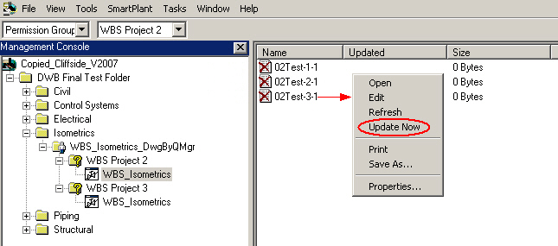

If multiple drawings under a single “WBS_Isometrics” component have been created, some or all of them can be updated simultaneously simply by selecting the desired drawings, right-clicking and picking the Update Now entry from the resulting shortcut menu.

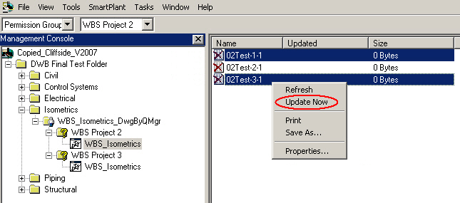

If multiple drawings at multiple locations in the hierarchy have been created, all of them can be updated simultaneously simply by right-clicking any component or folder that functions as a hierarchal parent of all of the desired drawings and picking the Update Now entry from the resulting shortcut menu.

